https://explore.skillbuilder.aws/learn/course/134/play/31418/aws-cloud-practitioner-essentials-all-modules

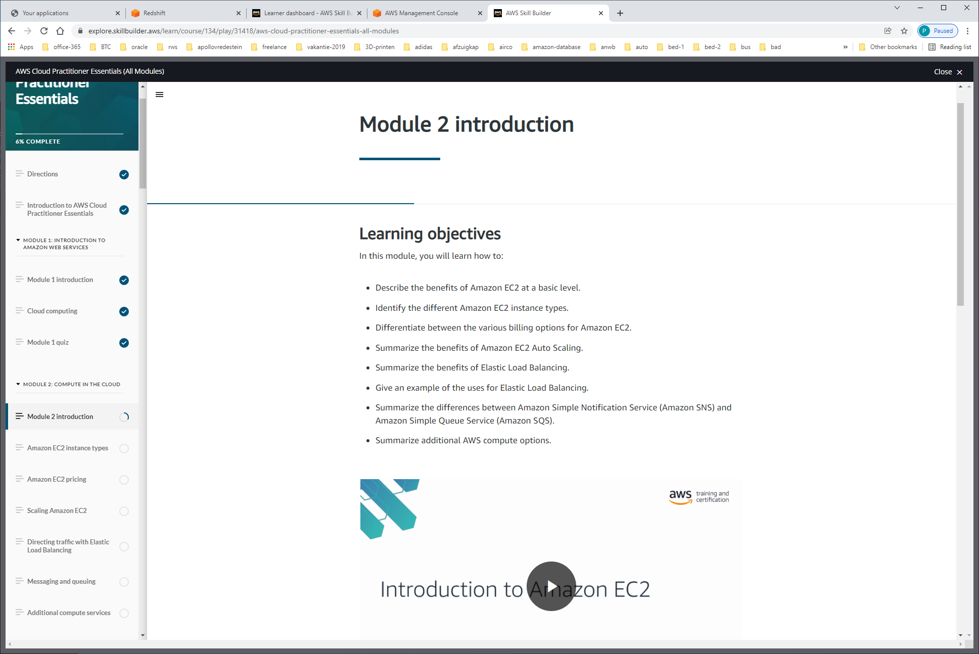

**Amazon Elastic Compute Cloud (Amazon EC2) = COMPUTE-AS-A-SERVICE !!!!**

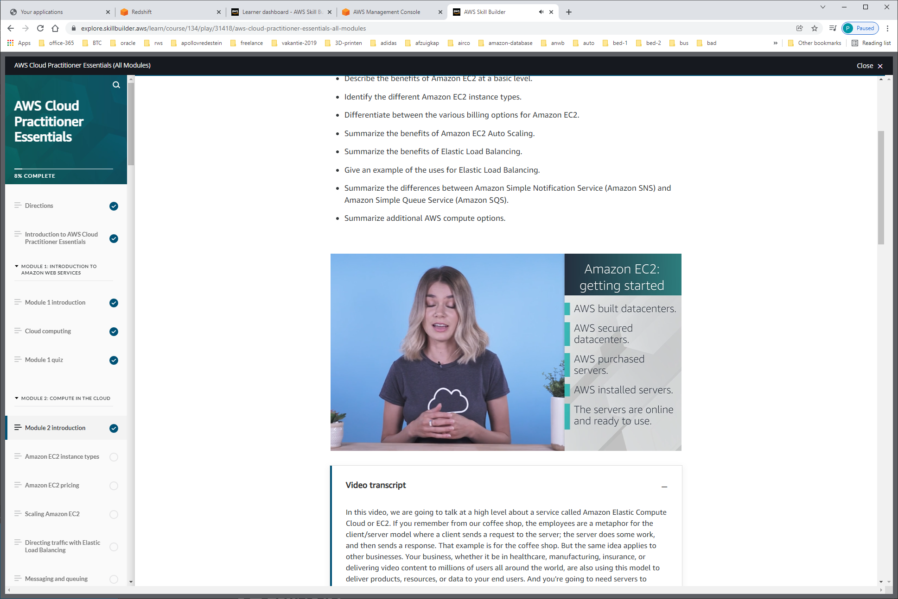

EC2 runs on top of physical host machines managed by AWS using virtualization technology. When you spin up an EC2 instance, you aren't necessarily taking an entire host to yourself. Instead, you are sharing the host with multiple other instances, otherwise known as virtual machines. And a hypervisor running on the host machine is responsible for sharing the underlying physical resources between the virtual machines. This idea of sharing underlying hardware is called multitenancy. The hypervisor is responsible for coordinating this multitenancy and it is managed by AWS. The hypervisor is responsible for isolating the virtual machines from each other as they share resources from the host. This means EC2 instances are secure. Even though they may be sharing resources, one EC2 instance is not aware of any other EC2 instances also on that host. They are secure and separate from each other.

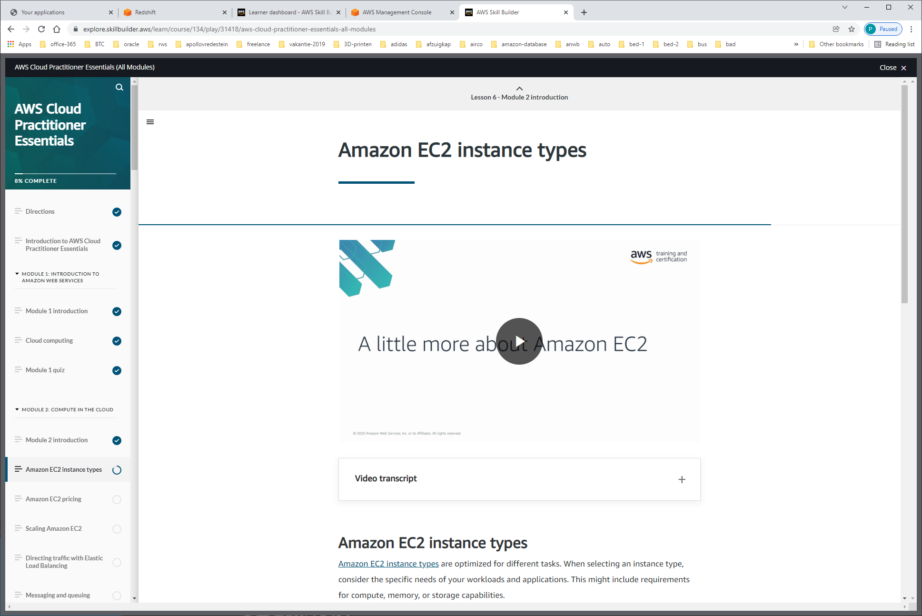

Instance-types

**General purpose instances** provide a balance of compute, memory, and networking resources. You can use them for a variety of workloads, such as:

* application servers
* gaming servers
* backend servers for enterprise applications
* small and medium databases

Suppose that you have an application in which the resource needs for compute, memory, and networking are roughly equivalent. You might consider running it on a general purpose instance because the application does not require optimization in any single resource area.

**Compute optimized instances** are ideal for compute-bound applications that benefit from high-performance processors. Like general purpose instances, you can use compute optimized instances for workloads such as web, application, and gaming servers.

However, the difference is compute optimized applications are ideal for high-performance web servers, compute-intensive applications servers, and dedicated gaming servers. You can also use compute optimized instances for batch processing workloads that require processing many transactions in a single group.

**Memory optimized instances** are designed to deliver fast performance for workloads that process large datasets in memory. In computing, memory is a temporary storage area. It holds all the data and instructions that a central processing unit (CPU) needs to be able to complete actions. Before a computer program or application is able to run, it is loaded from storage into memory. This preloading process gives the CPU direct access to the computer program.

Suppose that you have a workload that requires large amounts of data to be preloaded before running an application. This scenario might be a high-performance database or a workload that involves performing real-time processing of a large amount of unstructured data. In these types of use cases, consider using a memory optimized instance. Memory optimized instances enable you to run workloads with high memory needs and receive great performance.

**Accelerated computing instances** use hardware accelerators, or coprocessors, to perform some functions more efficiently than is possible in software running on CPUs. Examples of these functions include floating-point number calculations, graphics processing, and data pattern matching.

In computing, a hardware accelerator is a component that can expedite data processing. Accelerated computing instances are ideal for workloads such as graphics applications, game streaming, and application streaming.

**Storage optimized instances** are designed for workloads that require high, sequential read and write access to large datasets on local storage. Examples of workloads suitable for storage optimized instances include distributed file systems, data warehousing applications, and high-frequency online transaction processing (OLTP) systems.

In computing, the term input/output operations per second (IOPS) is a metric that measures the performance of a storage device. It indicates how many different input or output operations a device can perform in one second. Storage optimized instances are designed to deliver tens of thousands of low-latency, random IOPS to applications.

You can think of input operations as data put into a system, such as records entered into a database. An output operation is data generated by a server. An example of output might be the analytics performed on the records in a database. If you have an application that has a high IOPS requirement, a storage optimized instance can provide better performance over other instance types not optimized for this kind of use case.

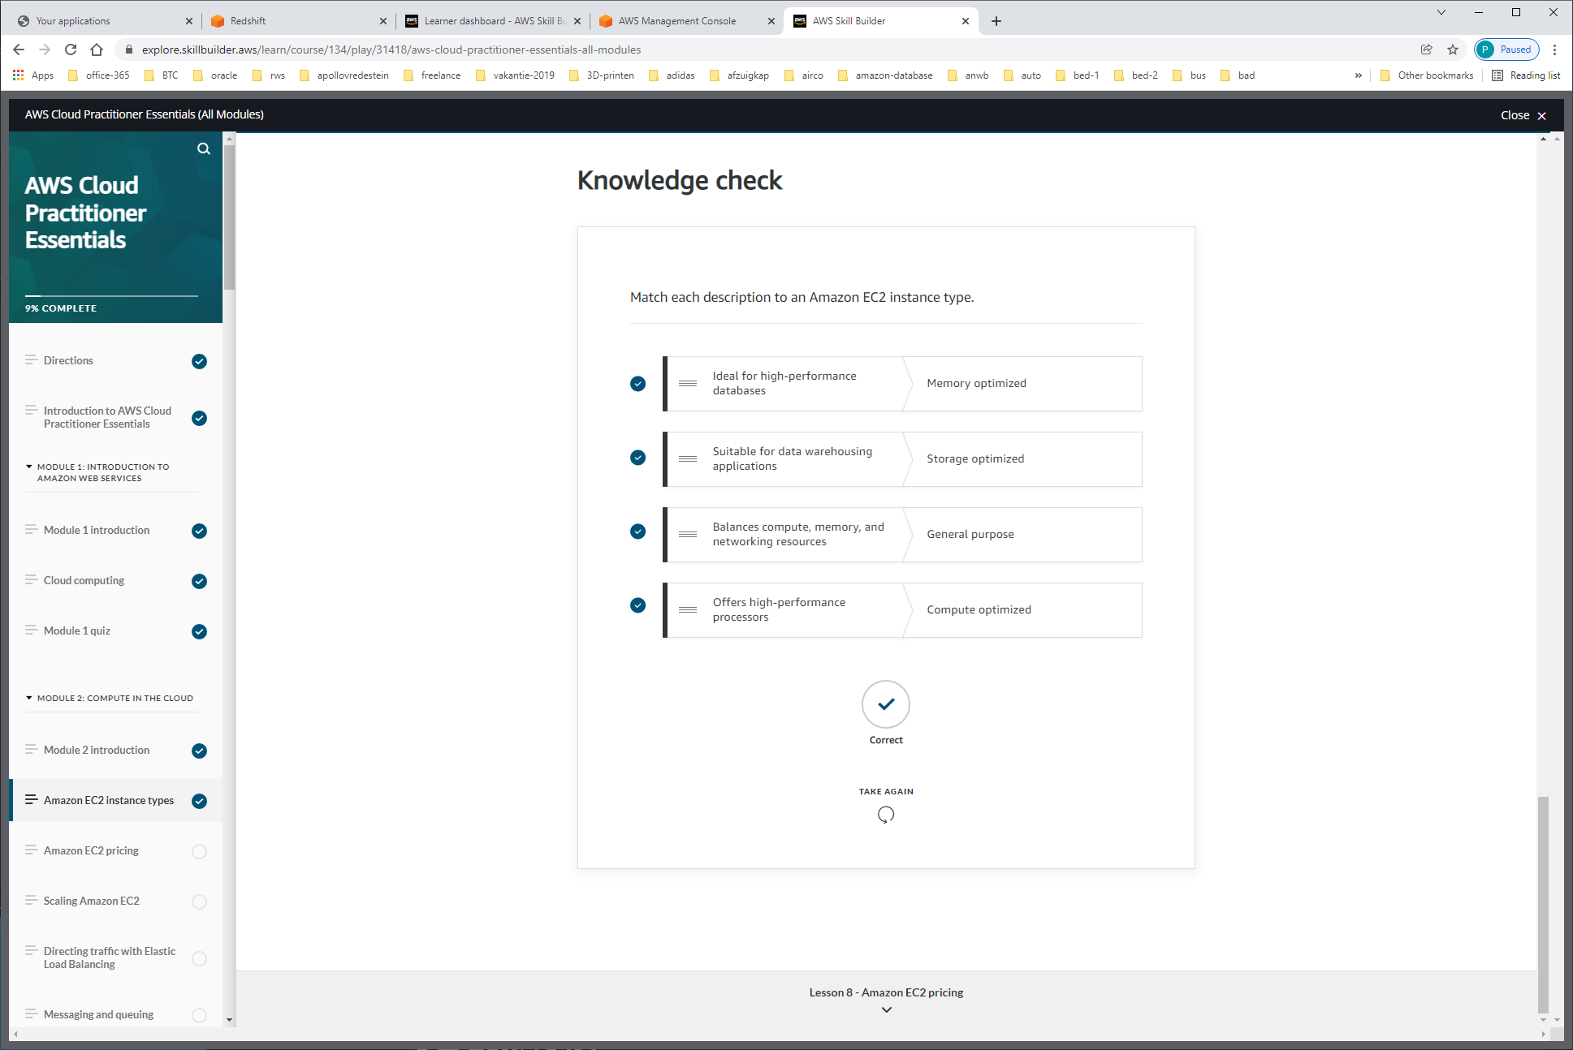

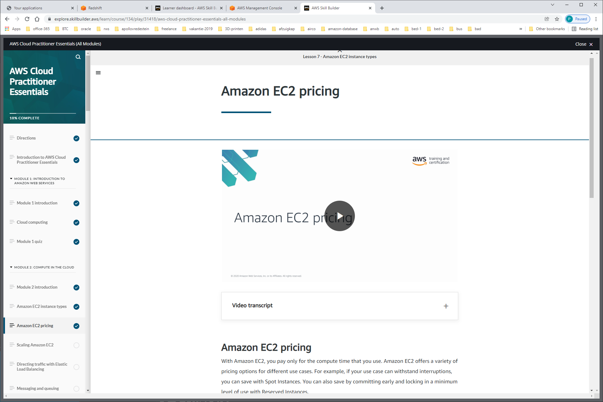

With Amazon EC2, you pay only for the compute time that you use.

Pricing options

**On-Demand Instances** are ideal for short-term, irregular workloads that cannot be interrupted. No upfront costs or minimum contracts apply. The instances run continuously until you stop them, and you pay for only the compute time you use.  
Sample use cases for On-Demand Instances include developing and testing applications and running applications that have unpredictable usage patterns. On-Demand Instances are not recommended for workloads that last a year or longer because these workloads can experience greater cost savings using Reserved Instances.

AWS offers Savings Plans for several compute services, including Amazon EC2. **Amazon EC2 Savings Plans** enable you to reduce your compute costs by committing to a consistent amount of compute usage for a 1-year or 3-year term. This term commitment results in savings of up to 66% over On-Demand costs.

Any usage up to the commitment is charged at the discounted plan rate (for example, $10 an hour). Any usage beyond the commitment is charged at regular On-Demand rates.

Later in this course, you will review AWS Cost Explorer, a tool that enables you to visualize, understand, and manage your AWS costs and usage over time. If you are considering your options for Savings Plans, AWS Cost Explorer can analyze your Amazon EC2 usage over the past 7, 30, or 60 days. AWS Cost Explorer also provides customized recommendations for Savings Plans. These recommendations estimate how much you could save on your monthly Amazon EC2 costs, based on previous Amazon EC2 usage and the hourly commitment amount in a 1-year or 3-year plan.

**Reserved Instances** are a billing discount applied to the use of On-Demand Instances in your account. You can purchase Standard Reserved and Convertible Reserved Instances for a 1-year or 3-year term, and Scheduled Reserved Instances for a 1-year term. You realize greater cost savings with the 3-year option.

At the end of a Reserved Instance term, you can continue using the Amazon EC2 instance without interruption. However, you are charged On-Demand rates until you do one of the following:

* Terminate the instance.
* Purchase a new Reserved Instance that matches the instance attributes (instance type, Region, tenancy, and platform).

**Spot Instances** are ideal for workloads with flexible start and end times, or that can withstand interruptions. Spot Instances use unused Amazon EC2 computing capacity and offer you cost savings at up to 90% off of On-Demand prices.  
Suppose that you have a background processing job that can start and stop as needed (such as the data processing job for a customer survey). You want to start and stop the processing job without affecting the overall operations of your business. If you make a Spot request and Amazon EC2 capacity is available, your Spot Instance launches. However, if you make a Spot request and Amazon EC2 capacity is unavailable, the request is not successful until capacity becomes available. The unavailable capacity might delay the launch of your background processing job.  
  
After you have launched a Spot Instance, if capacity is no longer available or demand for Spot Instances increases, your instance may be interrupted. This might not pose any issues for your background processing job. However, in the earlier example of developing and testing applications, you would most likely want to avoid unexpected interruptions. Therefore, choose a different EC2 instance type that is ideal for those tasks.

**Dedicated Hosts**are physical servers with Amazon EC2 instance capacity that is fully dedicated to your use.

You can use your existing per-socket, per-core, or per-VM software licenses to help maintain license compliance. You can purchase On-Demand Dedicated Hosts and Dedicated Hosts Reservations. Of all the Amazon EC2 options that were covered, Dedicated Hosts are the most expensive.

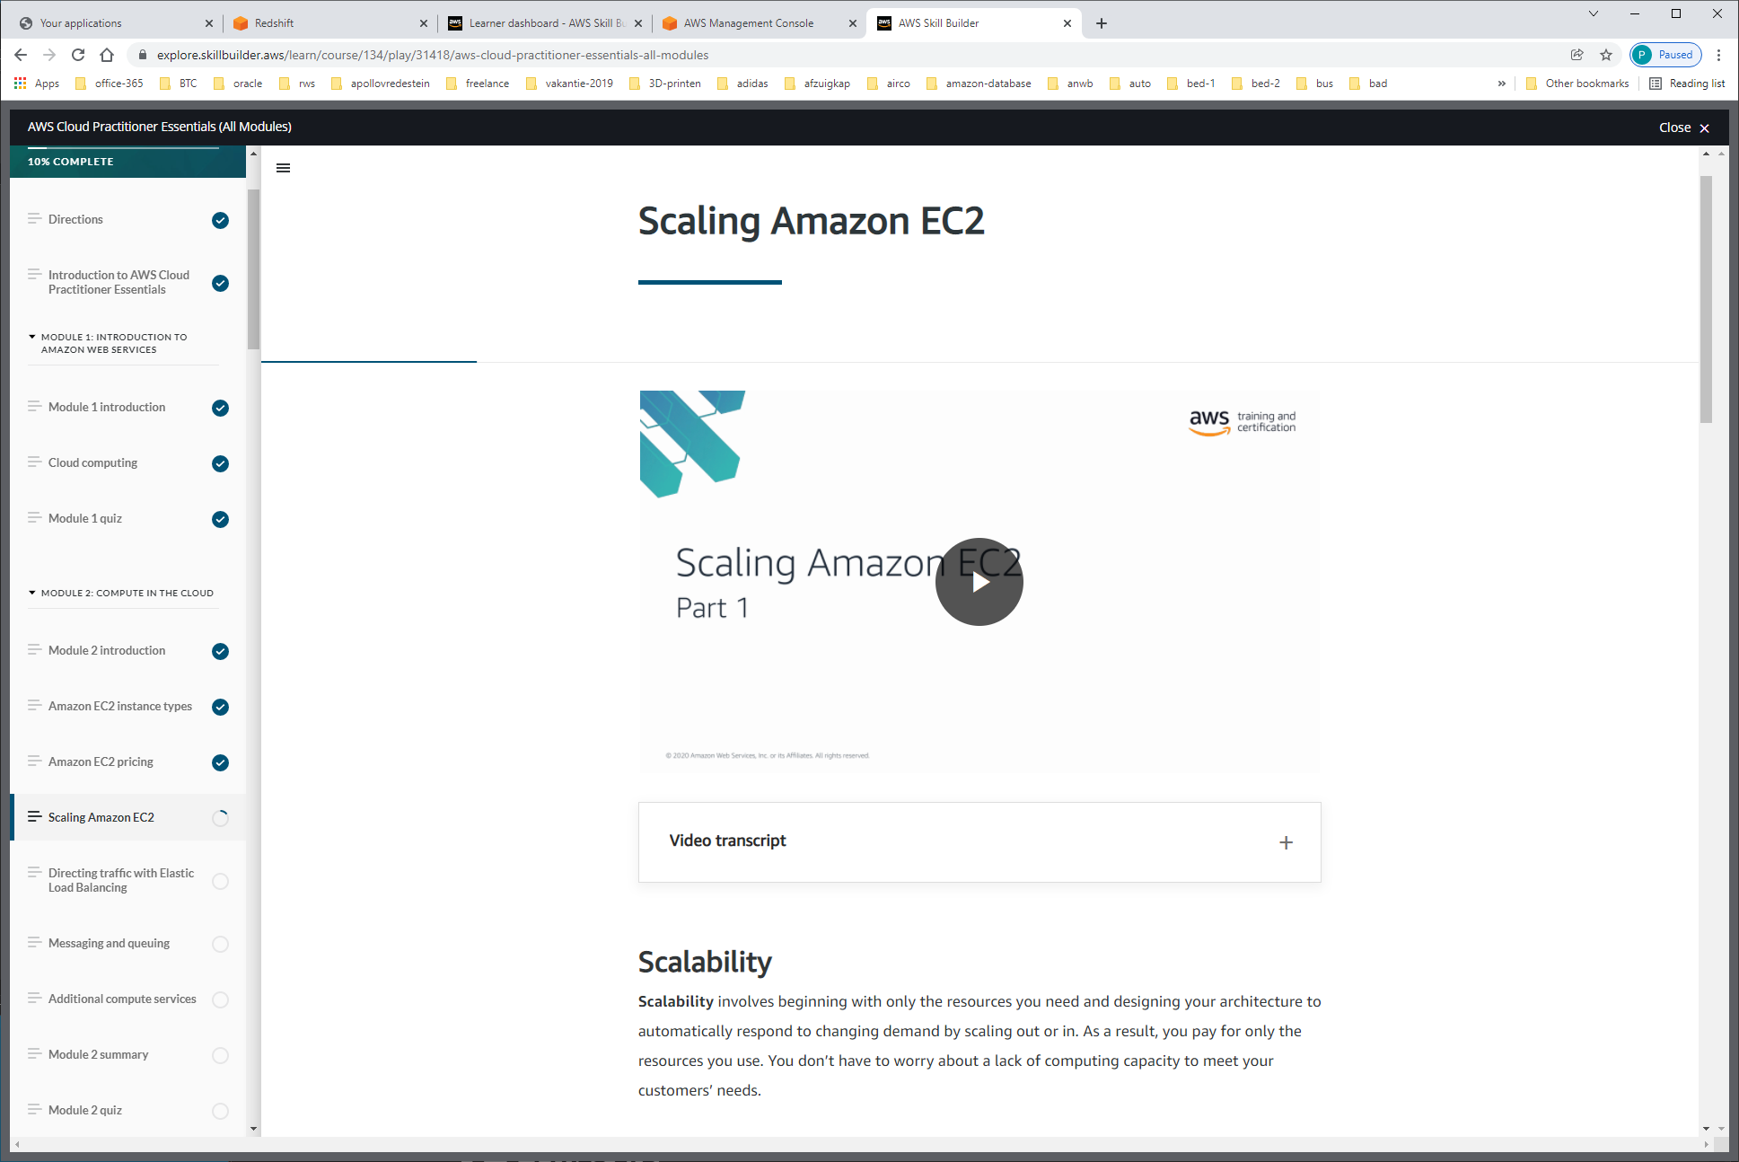

**Scalability** involves beginning with only the resources you need and designing your architecture to automatically respond to changing demand by scaling out or in. As a result, you pay for only the resources you use. You don’t have to worry about a lack of computing capacity to meet your customers’ needs.

If you wanted the scaling process to happen automatically, which AWS service would you use? The AWS service that provides this functionality for Amazon EC2 instances is **Amazon EC2 Auto Scaling**. Within Amazon EC2 Auto Scaling, you can use two approaches: dynamic scaling and predictive scaling.  
*-Dynamic scaling* responds to changing demand.   
*-Predictive scaling*automatically schedules the right number of Amazon EC2 instances based on predicted demand.

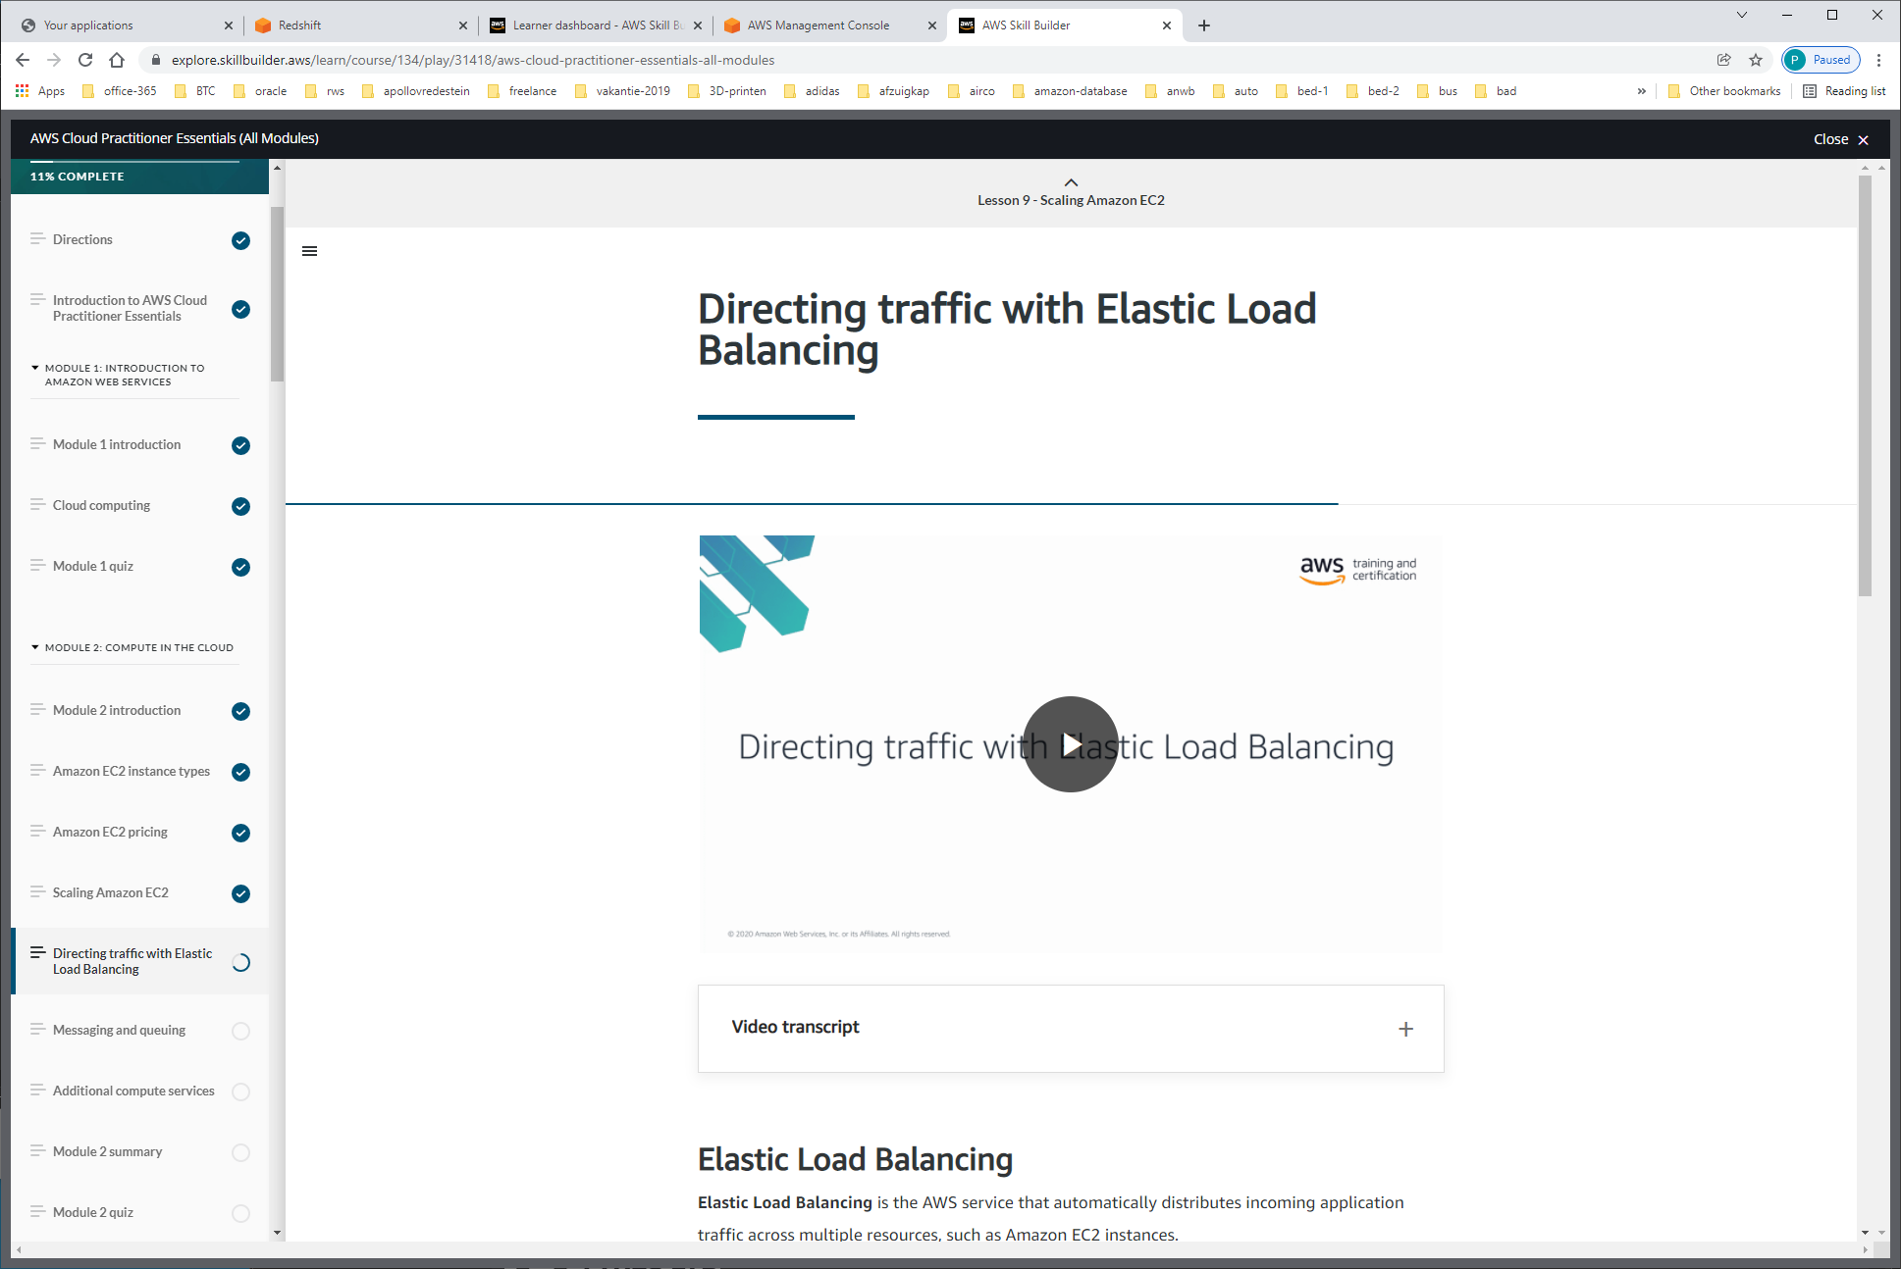

**Elastic Load Balancing** is the AWS service that automatically distributes incoming application traffic across multiple resources, such as Amazon EC2 instances.

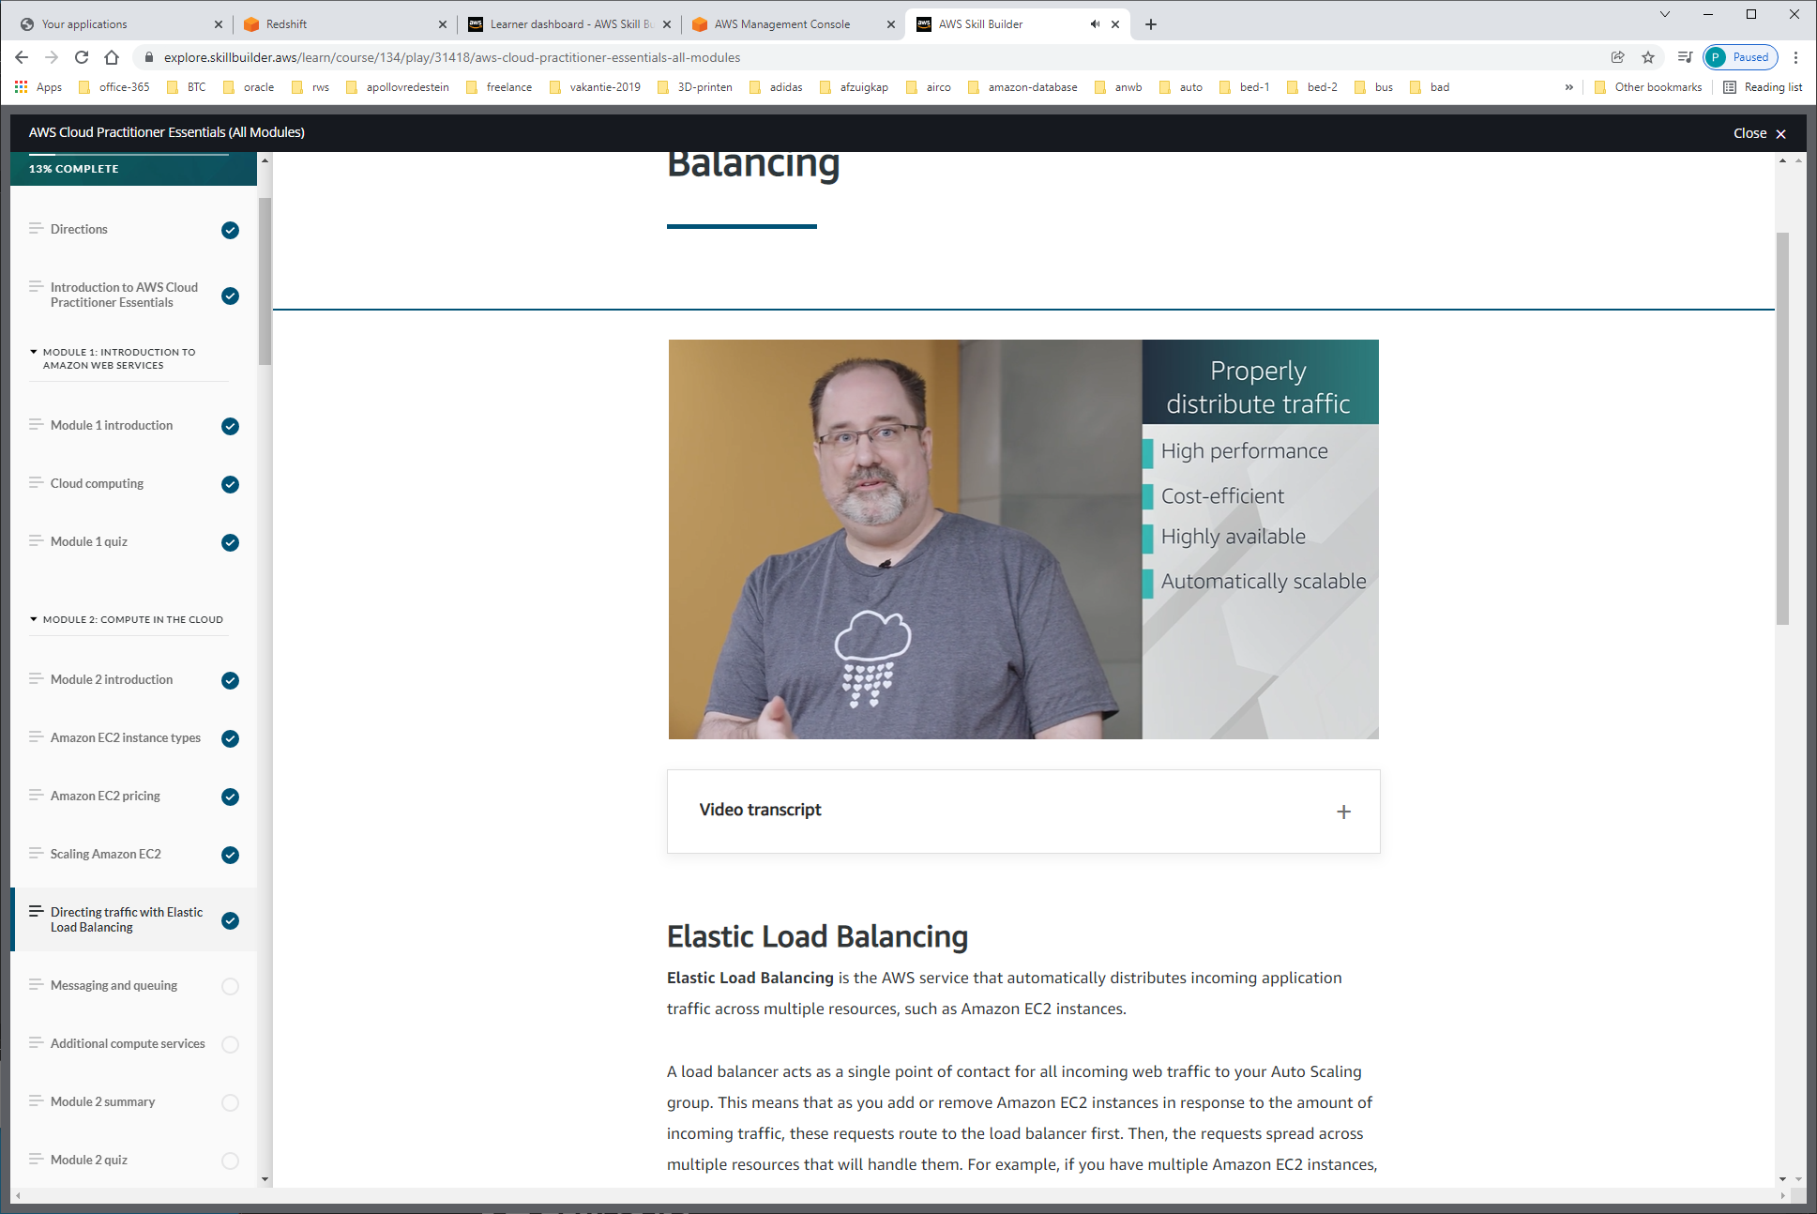

ELB = WERKT OP region-level

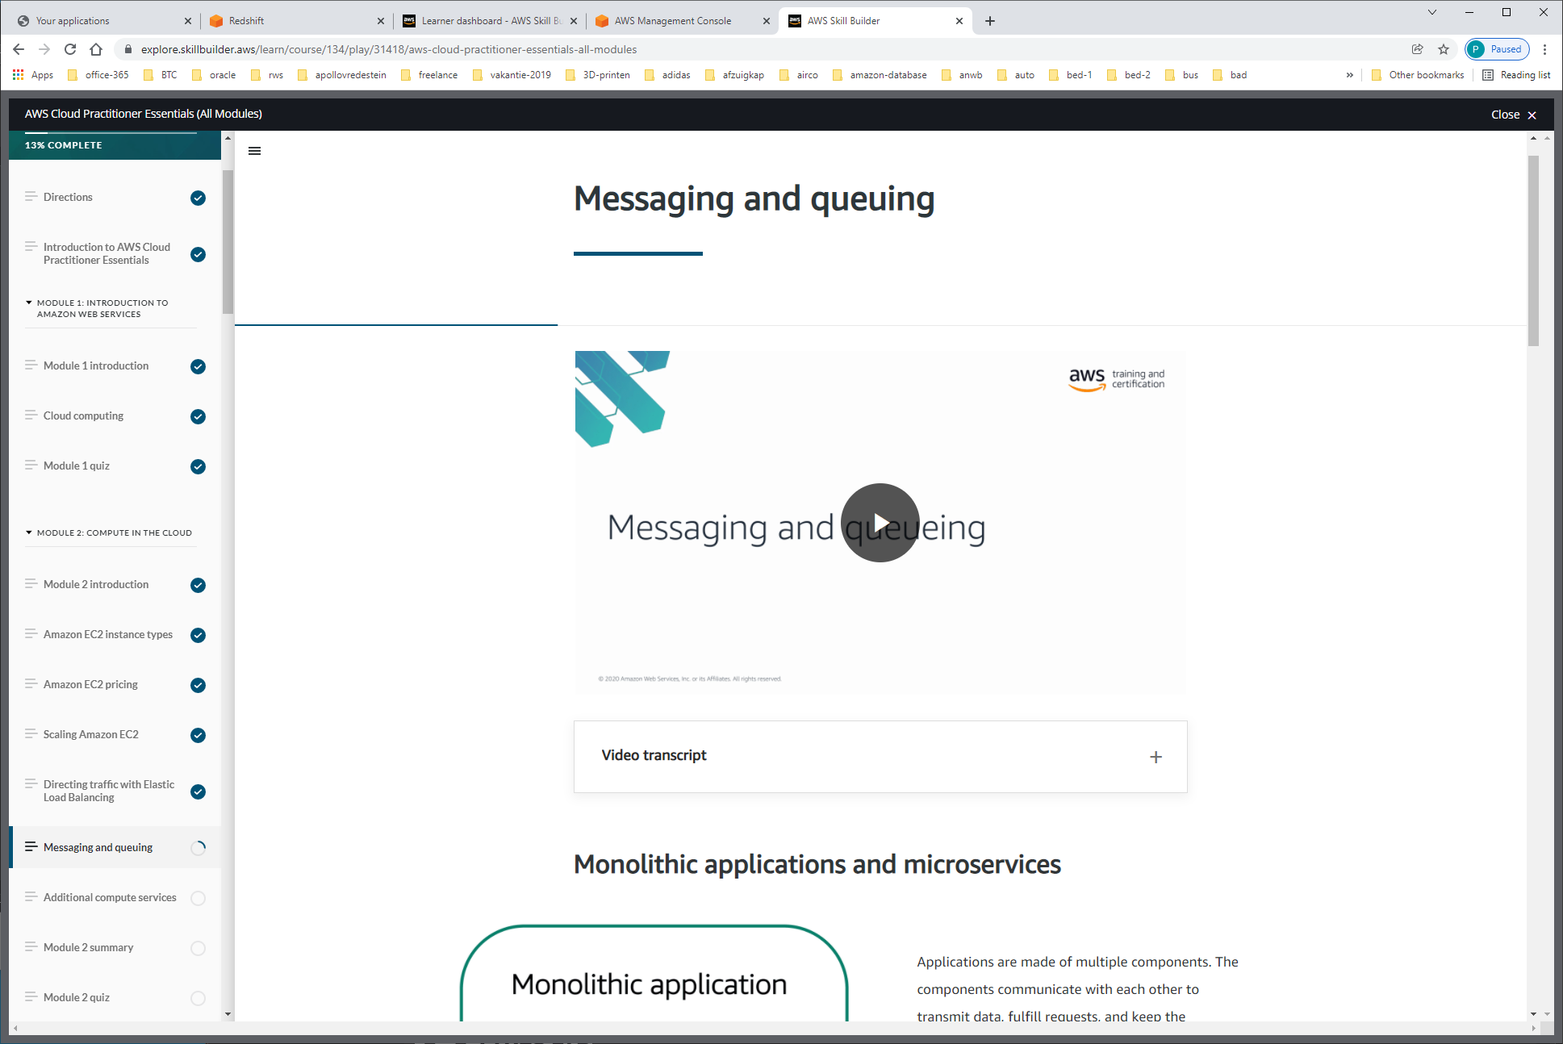

Two AWS services that can assist in this regard. Amazon Simple Queue Service or SQS and Amazon Simple Notification Service or SNS.

**SQS** allows you to send, store, and receive messages between software components at any volume. This is without losing messages or requiring other services to be available.

**Amazon SNS** is similar in that it is used to send out messages to services, but it can also send out notifications to end users. It does this in a different way called a publish/subscribe or pub/sub model.

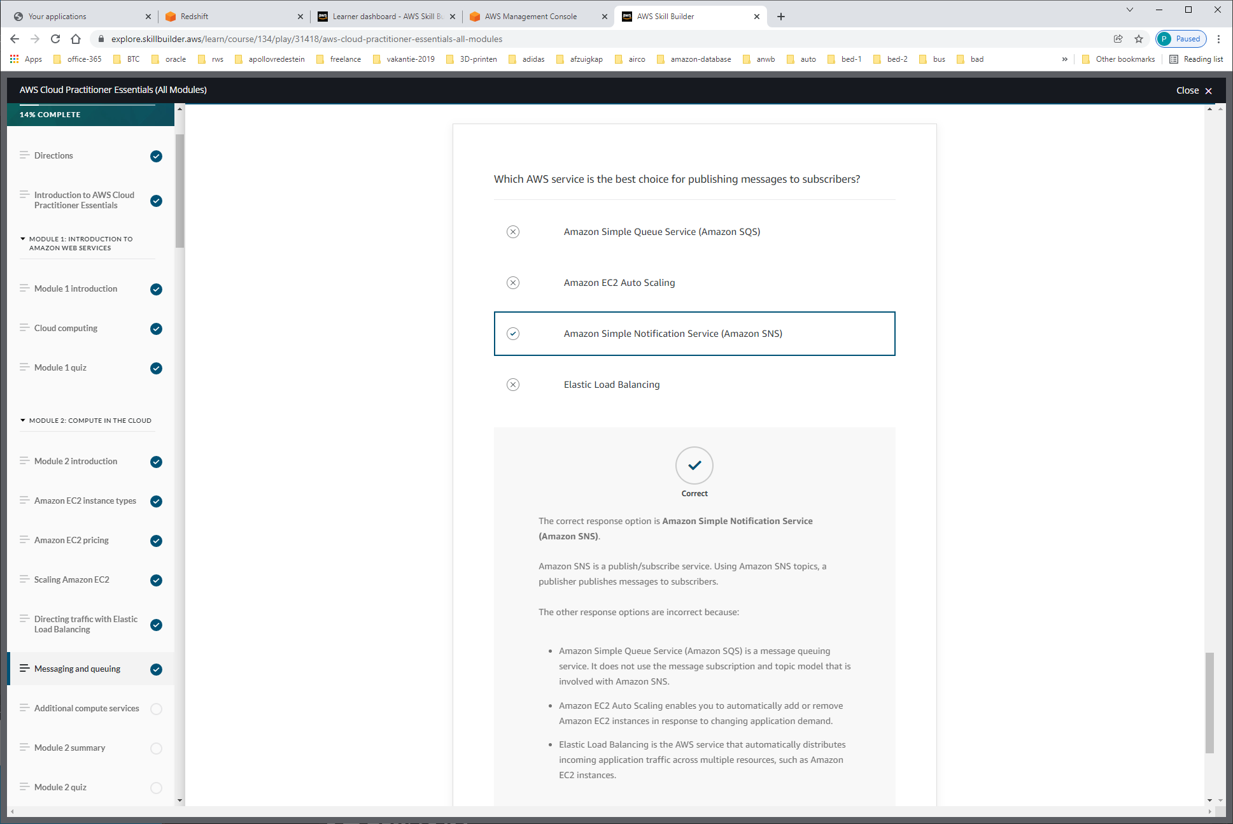

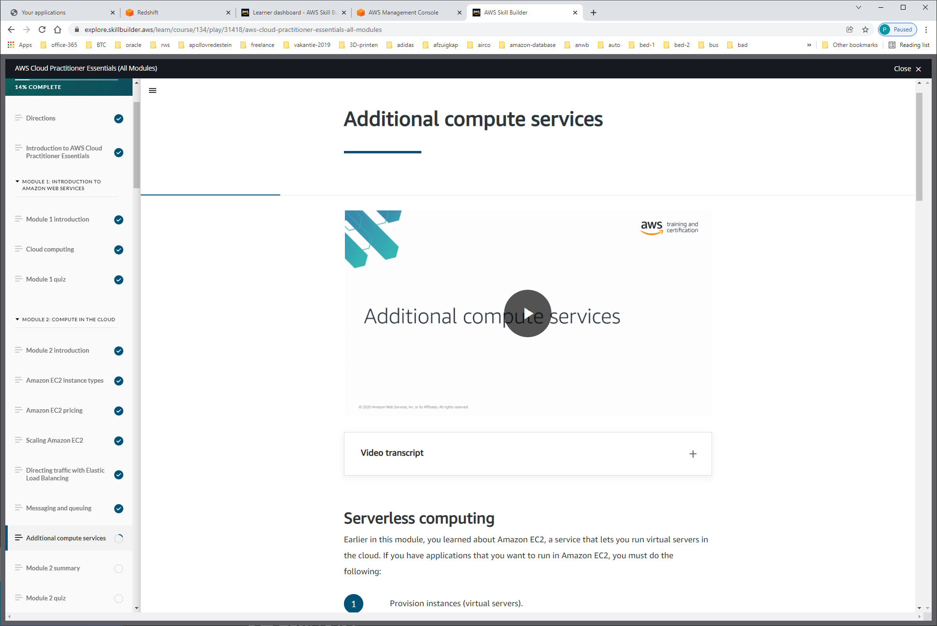

EC2 = FLEXIBLE / RELIABLE / SCALABLE

ZELF responsible voor: -Patching / provisioning  
-Scaling  
-High-available

Serverless-compute-options: MEANS: YOU CANNOT SEE OR ACCESS THE UNDERLYING INFRASTRUCTURE

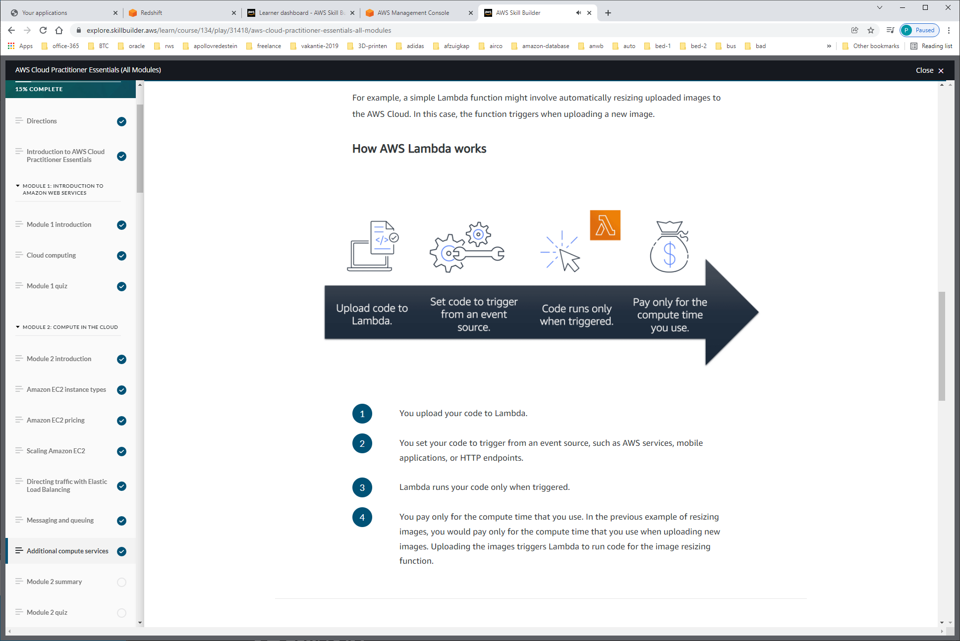

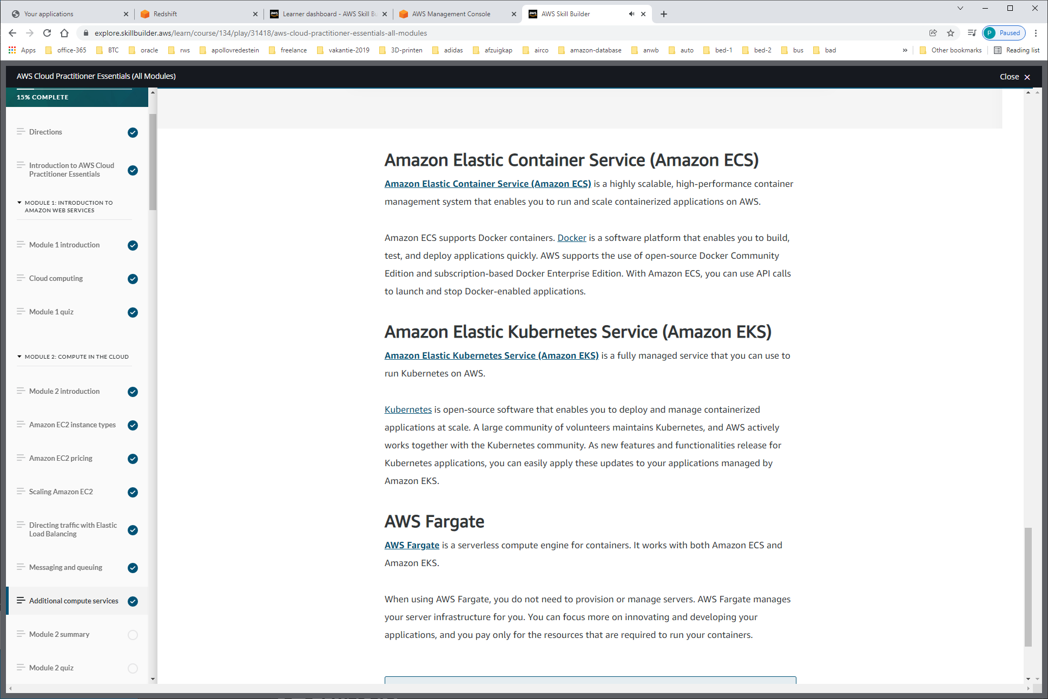

AWS-FARGATE= serverless compute platform voor ECS / EKS, als je niet op OS hoeft te zijn !!!

= gebruik LAMBDA



